Space Operation Summary

Bandwagon-5 (X4107) SpaceX Falcon 9 Launch
Cape Canaveral Space Force Station, Florida

Hazard Area Evaluation

The National Airspace System (NAS) hazard area evaluation examined three launch Aircraft Hazard Areas (AHAs) and the Special Use Airspace (SUA) associated with this launch. The first, AHA-A, extends from the launch site to 38nm southeastward, the second, AHA B, extends from 283nm southeast of the launch site to 422nm southeast and is within the Nassau FIR and Miami ARTCC airspace. A third AHA C safeguarding the Stage 2 reentry is located west of Californa in the Oakland and Mazatlan FIRs.

Anticipated Integration Mitigations

AHA lengths and locations will impact a portion of the Atlantic Routes. Affected airspace also includes Cape Restricted Areas, and portions of Warning Areas. Traffic Management Initiatives (TMIs) will include reroutes to structure traffic around the AHAs.

Images Below

Launch Zone Hazard Areas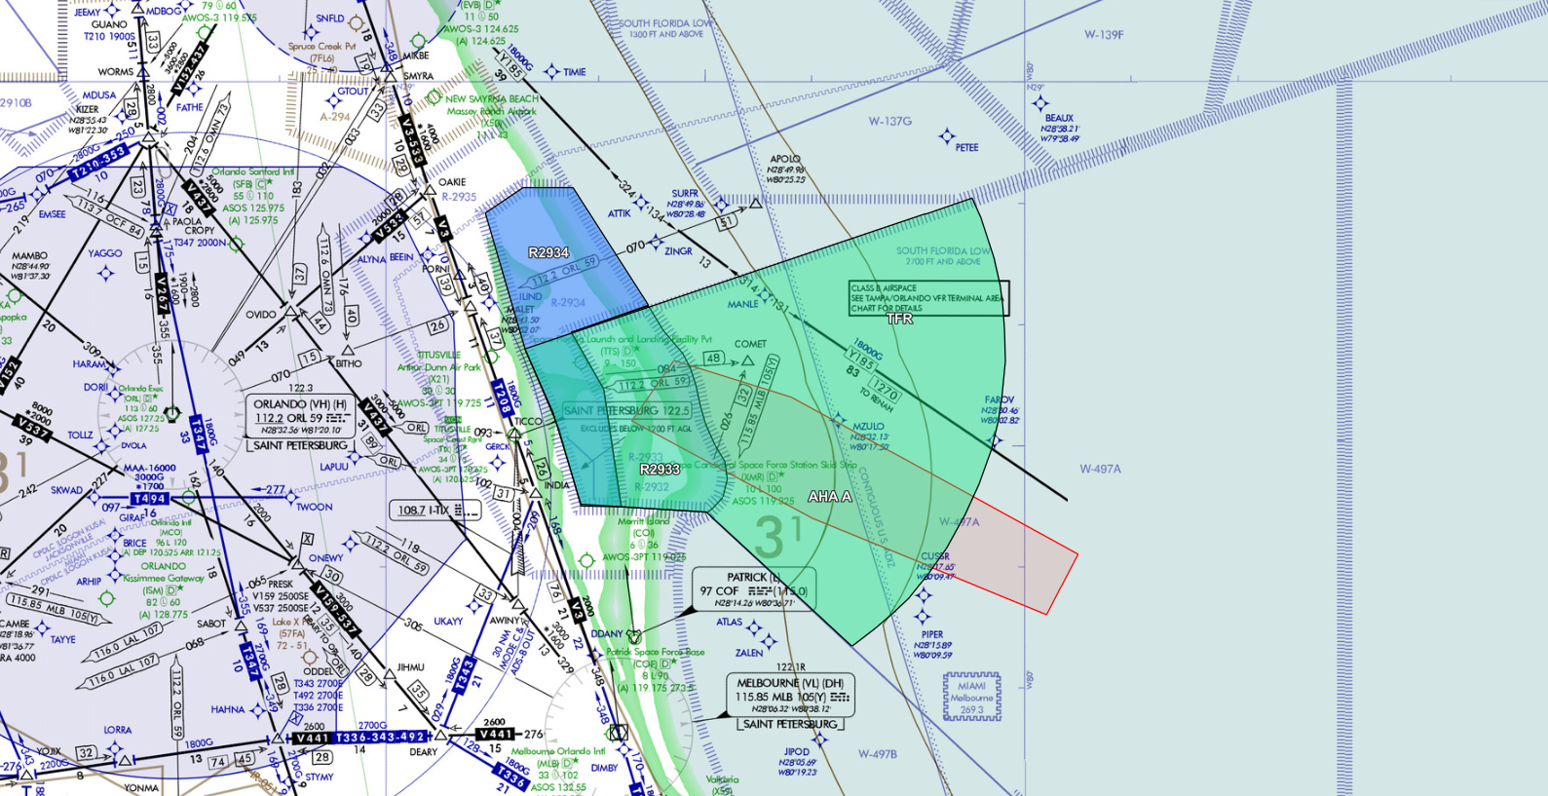

Aircraft Hazard Areas: AHA-A&B + DRA-1,2,3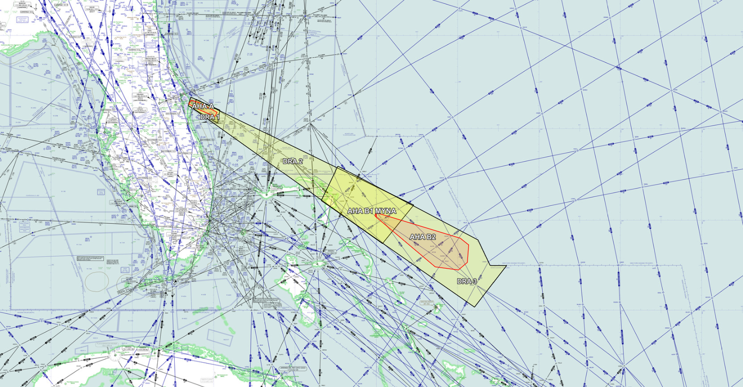

Image Below
Stage 2 Reentry Hazard Area – Oakland and Mazatlan FIRs


